LAB REPORT – 8
Bus-based ALU-Register Data Transaction

Name: Basireddy Khyathi Sri
Roll No: 2023102065
Table No: 3

OBJECTIVE:

We are expected to construct and investigate data transactions via a
BUS-based system in this project.

ELECTRONIC COMPONENTS REQUIRED:

1)4-bit Arithmetic Logic Unit (74LS181)
2)Operand Register (CD4035),
3)Accumulator Register (CD4076)
4) Tri-State Buffer (74LS125), Some wires,
5)Breadboard
6)Switches (Input Pins)
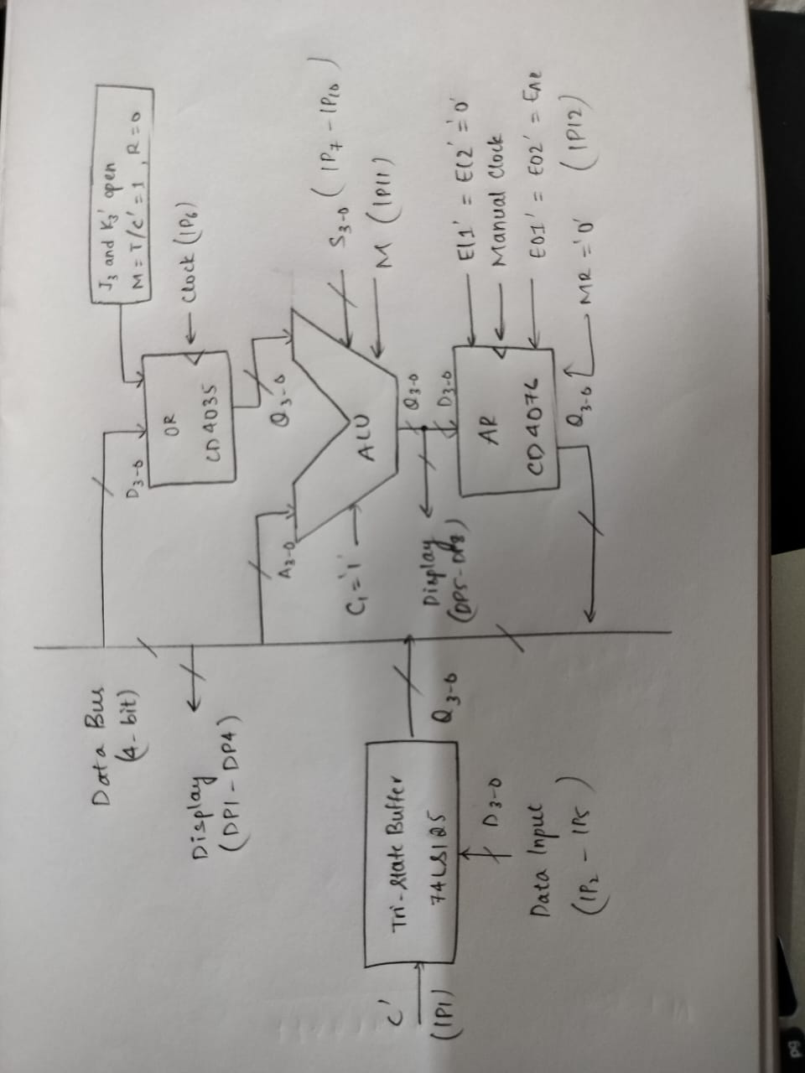
7)LEDs (Display Pins) and Power supply.

REFERENCE CIRCUIT:
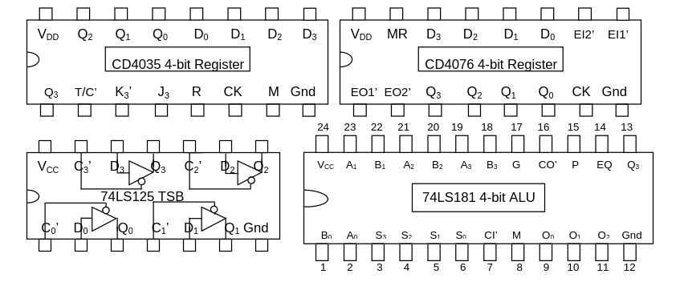
PIN DIAGRAMS of all the IC’s required:

MAKE THE BELOW CONNECTIONS :

Connections for Tri - State Buffer (74LS125):
- Connect All C0,C1,C2,C3 to Input Pin 1.
- Connect D3,D2,D1,D0 to Input Pins 2,3,4,5, respectively.
- Connect Q3,Q2,Q1,Q0 to the lines above and below on the
- breadboard (DATA LINES).
- Connect Q3,Q2,Q1,Q0 to the Display Pins 1,2,3,4 through data lines.

Connections for Operand Register (CD4035):
- Connect M and T/C’ to VCC .
- Connect R to Ground.
- Connect CK to Input Pin 6 (which is to be used as a clock).
- Remain J3 and K3’ open.
- Connect Q0,Q1,Q2,Q3 on Operand Register (CD4035) to
- B0,B1,B2,B3 on Arithmetic Logic Unit.
- Connect D0,D1,D2,D3 on Operand Register (CD4035) to
- Q0,Q1,Q2,Q3 on Tri -State Buffer using data lines.

Connections for 4-bit Arithmetic Logic Unit (74LS181):
- Connect A0,A1,A2,A3 on Arithmetic Logic Unit (74LS181) to
- Q0,Q1,Q2,Q3 on Tri - State Buffer using data lines.
- Connect CI’ to VCC.
- Connect S0,S1,S2,S3 to Input Pins 7,8,9,10, respectively.
- Connect M to Input Pin 11.
- Connect Q0,Q1,Q2,Q3 Display Pins 8,7,6,5.
- Connect Q0,Q1,Q2,Q3 to D0,D1,D2,D3 on Accumulator Register
- (CD4076).

Connections for Accumulator Register (CD4076):
- Connect EI1’,EI2’MR to Ground.
- Connect CK to Manual Clock.
- Connect both EO1’ and EO2’ together. It is named EA and connect it
- to Input Pin 12.
- Connect Q0,Q1,Q2,Q3 to the data lines.

PROCEDURE:

1) The breadboard is powered by ground and vcc.
2) Connect the circuits in the manner described above (do not connect
the CD4076 circuit).
3) All of the DP1–DP4 LEDs should be off when C' = 1, indicating that
either the bus is "floating" or a digital output isn't being "driven" to the
appropriate logic level.
4) Check that the ALU function table connections are made correctly.
5) Finish the Accumulator Register connections.
6) The circuit is now configured to handle sequential data transactions
over the bus; however, in order to avoid BUS CONFLICT, which may arise
if the Tri-State Buffer and Accumulator Register, two possible sources of
data to be put on the bus, are both enabled, great caution must be
exercised during this portion of the experiment.
at the same TIME . At this stage of the experiment, great caution must
be exercised to prevent BUS CONFLICT, which can occur if the two
possible sources of data to be put on the bus—the Tri-State Buffer and
Accumulator Register—are both enabled. The circuit is now configured
to handle sequential data transactions over the bus.
7. Make sure that C' (IP1) and EAR' (IP12) are not both LOW before
turning it back on.
8. Perform a series of three to four carefully selected ALU operations
with the same number in OR, and then see the complete sequence of
ALU outputs displayed.

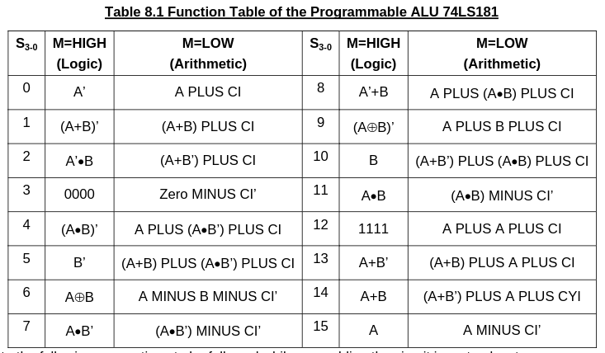

For TRI – STATE BUFFER:

S.No | Enable | Input | Output | Observation
1. | 0 | 1 | 0 | High Impedance
2. | 0 | 0 | 0 | High Impedance
3. | 1 | 0 | 0 | Bus is DRIVEN
4. | 1 | 1 | 1 | Bus is DRIVEN

INPUTS for Operand Register and Accumulator Register:
INPUTS | D3 | D2 | D1 | D0
0 | 0 | 0 | 0 | 0
1 | 0 | 0 | 0 | 1
2 | 0 | 0 | 1 | 0
3 | 0 | 0 | 1 | 1
4 | 0 | 1 | 0 | 0
5 | 0 | 1 | 0 | 1
6 | 0 | 1 | 1 | 0
7 | 0 | 1 | 1 | 1
8 | 1 | 0 | 0 | 0
9 | 1 | 0 | 0 | 1
10 | 1 | 0 | 1 | 0
11 | 1 | 0 | 1 | 1
12 | 1 | 1 | 0 | 0
13 | 1 | 1 | 0 | 1
14 | 1 | 1 | 1 | 0
15 | 1 | 1 | 1 | 1

CONCLUSION:
Using tristate buffers, we were able to successfully move data (the output of one register) from one register to another through bus. In summary, the 74LS181 bus-based ALU-register data transaction experiment.
The efficiency of these parts in a computer system was successfully demonstrated using an ALU, two CD4035 and CD4076 registers, and a 74LS125 Tri-State Buffer. The outcomes demonstrate that the components could carry out the required arithmetic.

